Complex and Critical Perspectives on Learning
The Scholarly Consortium for Innovative Psychology in Education
October 3-4, 2019
Embassy Suites by Hilton Historic Savannah in downtown Savannah

The Scholarly Consortium for Innovative Psychology in Education (SCIPIE) is a professional organization devoted to the study of psychology in education. At the core of SCIPIE are devoted consortium members who maintain leadership roles in educational research around the country. SCIPIE was created to bring together education scholars to advance the study of learning and to provide graduate students with opportunities for participation in authentic problem solving and dialogue. Our emphasis is on research currently in progress and difficult problems that researchers face in our areas of foci. The organization is focused on maintaining a center for innovation in the psychological study of learning.

The focus for the 2019 conference is exploring complex and critical perspectives on psychological processes in education in order to reimagine existing strands of research and generate new trajectories for the field. Two areas where educational psychology has begun to make advances is by illuminating the complex, dynamic, and emergent processes of learning, as well as by examining the ideological, cultural, political, and historical forces that shape power and privilege embedded in our understanding of learning.

This year’s program is organized into three strands: Methods Workshops, Critical and Complex Conversations, and Policy Considerations.
THURSDAY, OCTOBER 3, 2019

BREAKFAST/NETWORKING 6:00AM TO 9:00AM (hotel lobby restaurant)
CHECK IN/ON SITE REGISTRATION: 8:00-9:00 (TBD)
GRADUATE STUDENT POSTER HANGING BEGINS @ 8:00AM (Salon AB)

SESSION 1: 9:00AM TO 10:15AM
Welcome and Keynote Address by Dr. Jessica Decuir-Gunby (Location: Salon AB)
Centering Race in Educational Psychology: The Roles of Race Focused and Reimaged Constructs

Dr. Jessica T. DeCuir-Gunby is a Professor of Educational Psychology and Associate Department Head in the Department of Teacher Education and Learning Sciences at NC State University in Raleigh, North Carolina. DeCuir-Gunby was an inaugural recipient of the NC State University Faculty Scholar Award (2012-2013) and received the NC State University Research Award (2018). In addition, she was recognized by the University of Georgia’s College of Education by being awarded the 2015-2016 Alumni Outstanding Educator Award. DeCuir-Gunby's program of research focuses on three areas (1) race and racial identity (including Critical Race Theory); (2) research methods (with an emphasis on Mixed Methods); and (3) emotions and education. She explores how issues of race and racism, often using a critical race theory lens, impact African Americans across the lifespan and in various educational contexts. In addition, as a practical/applied methodologist, she examines the research process, teaching others how to utilize specific methodological approaches.
BREAK 10:15AM TO 10:45AM
SESSION 2: 10:45AM TO 12:15PM
METHODS WORKSHOPS | CRITICAL AND COMPLEX CONVERSATIONS | POLICY CONSIDERATIONS
Mixed Methods Research for Educational Psychology (Salon A)  This experiential learning session provides an overview of MMR designs and best practices, an opportunity to discuss and receive feedback on current MMR projects or ideas, and discuss challenges and barriers to MMR in educational psychology. Attendees are invited to bring their in-progress mixed methods research.  Ashley Vaughn, University of California; Peggy Shannon-Baker, Georgia Southern University; Ananya Matewos, Temple University | Dealing with –isms in the Classroom: Critical Discourse in the Moment (Salon B)  This experiential learning session uses the principles of dialogue and Multipartiality to equip participants with tools and pedagogies to challenge “-isms” in the classroom, support a variety of narratives, and promote learning. We will explore how use a sociocultural perspective and theory within the constraints of pedagogy to give meaning to the implications of both individual and collective narratives expressed in classrooms.  Robert O'Hara, Clemson University | Accreditation and the Future of Educational Psychology (Salon C)  The field of Educational Psychology has been experiencing transformative pressures for over 20 years. Some issues present opportunities for growth; other pressures have the potential to reduce the prestige and influence of Educational Psychology. This experiential learning session will explore the positive and negative reasons for creating an accrediting body within Educational Psychology to help address the issues facing the field currently and to position the field for the future.  Steve Whitney, University of Missouri; Joyce Alexander, Texas A&M University; Martin Jones, University of New Mexico
LUNCH & SCHOLARLY DISCOURSE: 12:15PM TO 1:15PM (hotel lobby restaurant)

SESSION 3: 1:15PM TO 2:45PM
Designing Race Focused and Reimaged Research (Salon A)  Society, and likewise, schools are becoming more racially/ethnically diverse. With that growth, schools have experienced an increase in racial/ethnic animus. There is a need to better understand the roles that race/ethnicity play in schools and the ways that educational psychology research can help with such understanding. This interactive session aims to help novice researchers learn how to design race focused and race reimaged research in educational psychology. Before the session, participants should click to read this article and listen to this podcast.  Jessica Decuir-Gunby, North Carolina State University | Social Networks: Theories, applications, and issues  (Salon B)  This interactive paper session will engage participants in discussing educational research as a complex phenomenon. Facilitators will provide an overview of social network analysis as an analytic technique synergistic with process-oriented, interaction-dependent theories. Emphasis is on addressing challenges with data, analyses, and inferences arising from enacting network-based approaches in real world settings.  Rachel Part, Gwen Marchand, & Jonathan Hilpert, University of Nevada Las Vegas |  | What Does Psychological Science have to Say about Educational Policy? (Salon C)  The occasion of the 125th anniversary of our field seems an opportune time to reflect on the goals of our profession (Alexander, 2018) and our responsibilities as educational psychologists. The goal of this interactive session is to engage the audience in an activity to explore the ways educational psychology research can be more influential to educational policy.  Sharon Nicohols, University of Texas at San Antonio; Helen Rose Fives, Montclair University
BREAK 2:45PM TO 3:00PM

SESSION 4: 3:00PM TO 4:30PM
Introduction to R Studio  (Salon A)  This introductory workshop is intended for participants who already have a working background and understanding of computing descriptive and inferential statistics, and for those who already know how to use statistical software like SPSS. Participants will walk away from this introductory workshop with a foundational knowledge on how to download and use R Studio for basic descriptive and inferential statistics. Participants should bring their own laptops along with any datasets they want to import into R Studio.  John Chancey & Mike Crowson, University of Oklahoma | Examining Methodologies to Capture Complex Phenomena related to Motivation and STEM Learning (Salon B)  This interactive paper session aims to explore a broad range of methodological approaches used to capture complex phenomena related to motivation and STEM learning, including: non-linear intra-inter-personal processes, dynamic processes motivation and learning at multiple levels, and ecological and sociocultural contexts in which students’ motivation and learning reside.  Christine Bae, Alison Koenka, Jason Chow & Michael Broda, Virginia Commonwealth University; Gwen Marchand, UNLV; Benjamin Heddy, University of Oklahoma, DeLeon Gray, North Carolina State | Exploring the Psychology of Learning: Paper Session  (Salon C)  Education and Aspirations of African American High School Students in Rural South Georgia: Meca Williams-Johnson & Kelly Childres, Georgia Southern University  Measuring Students’ Perceptions, Attitudes, and Beliefs at Scale: Socio-cultural Influences on Validity Evidence: Glenda Stump, MIT; Archana Mehendale, Tata Institute of Social Sciences  Exploring the Effects of an Open Classroom Climate on the Critical Consciousness of Preadolescent and Adolescent Youth: Luke J. Rapa, Candice Wicker Bolding, & Faiza M. Jamil, Clemson University
BREAK 4:30PM TO 5:00PM
GRADUATE STUDENT POSTER SESSION/ RECEPTION: 5:00PM TO 6:30PM (Salon AB)

FRIDAY, OCTOBER 4, 2019

BREAKFAST/NETWORKING 6:00AM TO 9:00AM (hotel lobby restaurant)
SESSION 1: 9:00AM TO 10:30AM
METHODS WORKSHOPS | CRITICAL AND COMPLEX CONVERSATIONS
Complexity Approaches to Analyzing Time Series Data (Salon A)  This interactive paper session aims to explore methodologies used to capture complex phenomena related to students’ motivation and STEM learning. Presentations will focus on sharing and discussing a broad range of methodological approaches used to understand the complexities of students’ motivation in STEM learning. Topics to be explored include: (a) Non-linear and/or intra- and inter-personal processes, (b) Dynamic processes (e.g., situationally-relevant, longitudinal patterns), (c) motivation and learning at multiple levels, and (d) ecological and sociocultural contexts in which motivation and learning reside.  Bernard Ricca, St. John Fisher College | Beyond the Brain: Embracing Embodied Cognition in Educational Research Settings (Salon B)  This experiential learning session introduces participants to embodied cognition as a research program including methodological approaches applicable to educational psychology. The facilitator will introduce theoretical foundations of embodied cognition using six themes: cognition is situated and contextual; cognition is a time-pressured, dynamical system functioning in real-time; the cognitive system is distributed between the physical body and the environment; cognition is off-loaded onto the environment; cognition is for action; and offline cognition is body-based.  Kristine Bragg, University of Nevada Las Vegas | Exploring the Psychology of Teaching: Paper session  (Salon C)  Complex Teacher Learning About Complex Argumentation in Science: The Case of Project ALSS: Michael Nussbaum & Michael S. Van Winkle, University of Nevada Las Vegas  Measuring Student Perceptions of Epistemic Instruction with Instructor Messages: Michelle Buehl & Angela Miller, George Mason University  Identifying ‘Best Practices,’ Responses, and Approaches for Teachable Moments: A Discussion on Conceptual Change Interventions: Marcus Johnson, Ashley Vaughn, Adam Chekour, University of Cincinnati; Gita Taasoobshirazi, Kennesaw State  Pre-Service Teachers as Designers: Shifts in quality of collaborative interaction across phases of an instructional design project: Denise Brown & Michelle Jordan, Arizona State University
BREAK 10:30AM TO 10:45AM

SESSION 2: 10:45AM TO 12:15PM
The Possibility and Peril of using multimodal physiological approaches to measure Academic Emotion, Race and Gender Bias, & Motivation (Salon A)  This experiential learning session aims to build on a SCIPIE 2017 workshop that introduced physiological research tools and techniques, affording researchers additional methods to study existing models of academic emotions. Psychological researchers are considering a variety of multimodal approaches that complement self-reports with techniques based on image analysis, biology, and physiological biomarkers. Multimodal physiological data can help us understand cultural phenomena such as implicit bias, white fragility, and stereotype threat without self-report bias. Facilitators will share practical and theoretical issues they have encountered and overcome.  Session co-leads: Idalis Villanueva (Utah State University) & Jenefer Husman (University of Oregon)  Session co-authors: Matthew C. Graham (University of Oregon), Darcie Christensen (Utah State University), Md. Tarique Hasan Khan (Utah State University); Session Facilitators: Keith Zvoch (University of Oregon); Makseem Skorodinsky (University of Oregon), Lisa Linnebrink-Garcia (Michigan State University) | Exploring Models of Responsive Professional Development: How might we help teachers negotiate identity and expand agency?  (Salon C)  This experiential learning session will engage attendees in collective reflection on design, implementation, and study of innovative models of in-service professional development (PD) that target the development of teacher identity, focus on teacher agency, and increase teachers’ perceived action possibilities, rather than focus exclusively on teachers’ knowledge and skill development. Innovative models are necessarily responsive to experienced teachers’ wants and needs, addressing their histories, contexts, goals and sociocultural identities. However, the emergent processes and outcomes of responsive PD introduce challenges for researchers seeking to investigate the efficacy of such PD models.  Michelle Jordan, Wendy Wakefield, & Melissa Warr, Arizona State University
LUNCH & SCHOLARLY DISCOURSE: 12:15AM TO 1:30PM (hotel lobby restaurant)
SESSION 3: 1:30PM TO 3:00PM
Qualitative Data Analysis on Complex Educational Psychological Phenomena (Salon A)  Recent advances in the study of psychological processes in education have embraced complexity theory, which views learning, motivation, and identity as emergent phenomena that reflect the dynamic interplay among physiological, psychosocial and sociocultural forces. Participants in the experiential learning session, will explore the Dynamic Systems Model of Role Identity (DSMRI) and learn how longitudinal qualitative data from interviews and open-ended writing prompts can be coded to reveal the complex and dynamic nature of role identities. Participants will receive access to the DSMRI manual.  Joanna Garner, Old Dominion University; Avi Kaplan, Temple University | Exploring the Psychology of Teaching & Learning: Paper session (Salon C)  Situating Educational Research in the Age of Digital Distraction: Abraham Flanigan, Georgia Southern University  Contribution of Language Skills to Peer Social Networks in Kindergarten: Jason Chow, Michael Broda, & Kristen Grander, Virginia Commonwealth University  Film School for Global Scientists: Teaching Students to Make Meaning in Multimodal Ways: Jessica Summers, Jill Castek, Veronica Oguilve, & Lia Falco, University of Arizona
BREAK 3:00PM TO 3:30PM
AWARDS AND RECAPITULATION 3:30PM TO 4:15PM (Salon AB)
The conference will conclude with a brief presentation of the founders award for the most innovative conference presentation and student poster awards, as well as concluding remarks by the keynote speaker, Dr. Jessica Decuir-Gunby, North Carolina State University

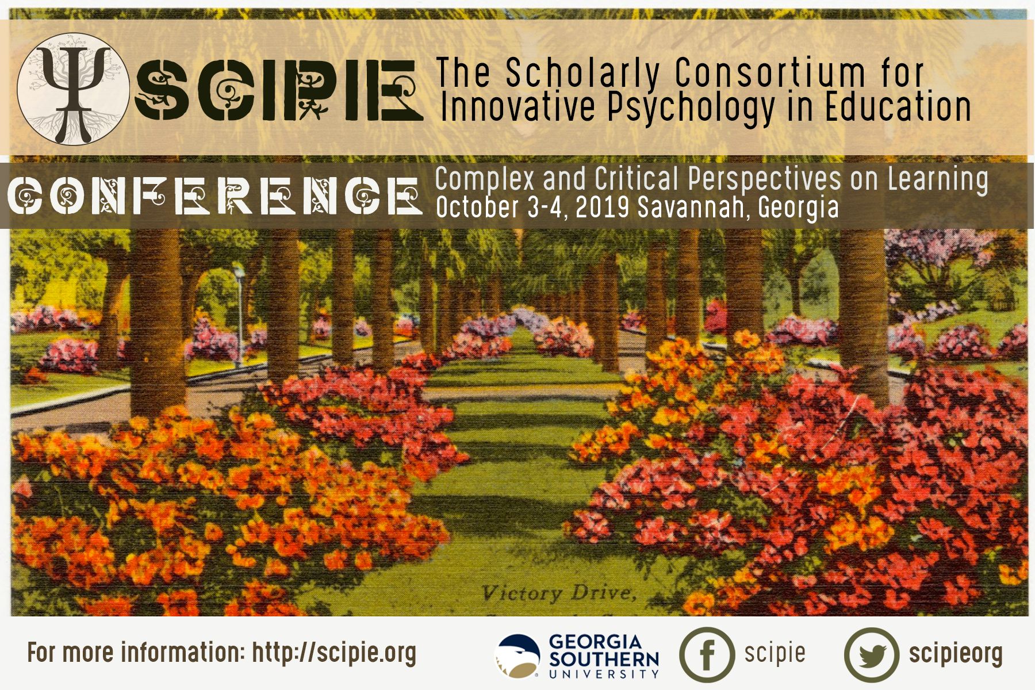

SCIPIE Board 2017-2019
President: Jonathan Hilpert, Ph.D., University of Nevada, Las Vegas
Past-President: Gwen Marchand, Ph.D., University of Nevada, Las Vegas
President-elect: Michelle Jordan, Ph.D., Arizona State University
Treasurer: Carolyn Hushman, Ph.D., University of New Mexico
Secretary: Denise Winsor, Ph.D., University of Memphis
Communications Coordinator: Karlyn Adams-Wiggins, Ph.D., Portland State
Member at Large: Martin Jones, Ph.D., University of New Mexico
Member at Large: Steven Whitney, Ph.D., University of Missouri
Technology Coordinator: Mete Akcaoglu, Ph.D., Georgia Southern University
THANKS
SCIPIE would like to extend a special thanks to our conference sponsors, Georgia Southern University and University of Nevada Las Vegas, as well as to the other member institutions that have provided resources and support to make the 2019 conference possible. We owe a debt of gratitude for everyone who has contributed to our organization. Thank you.

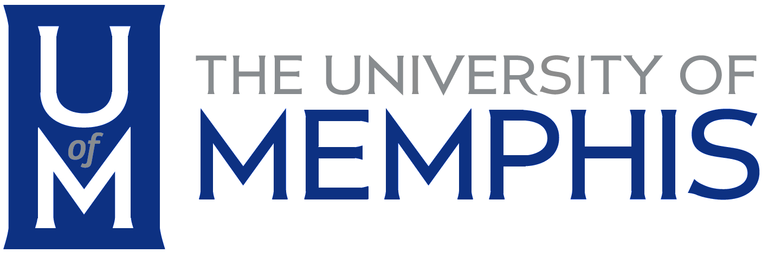

The SCIPIE 2019 conference was held in conjunction with the executive committee board meeting of Division 15 of the American Psychological Association. It was a privilege to collaborate with leaders of APA division 15!

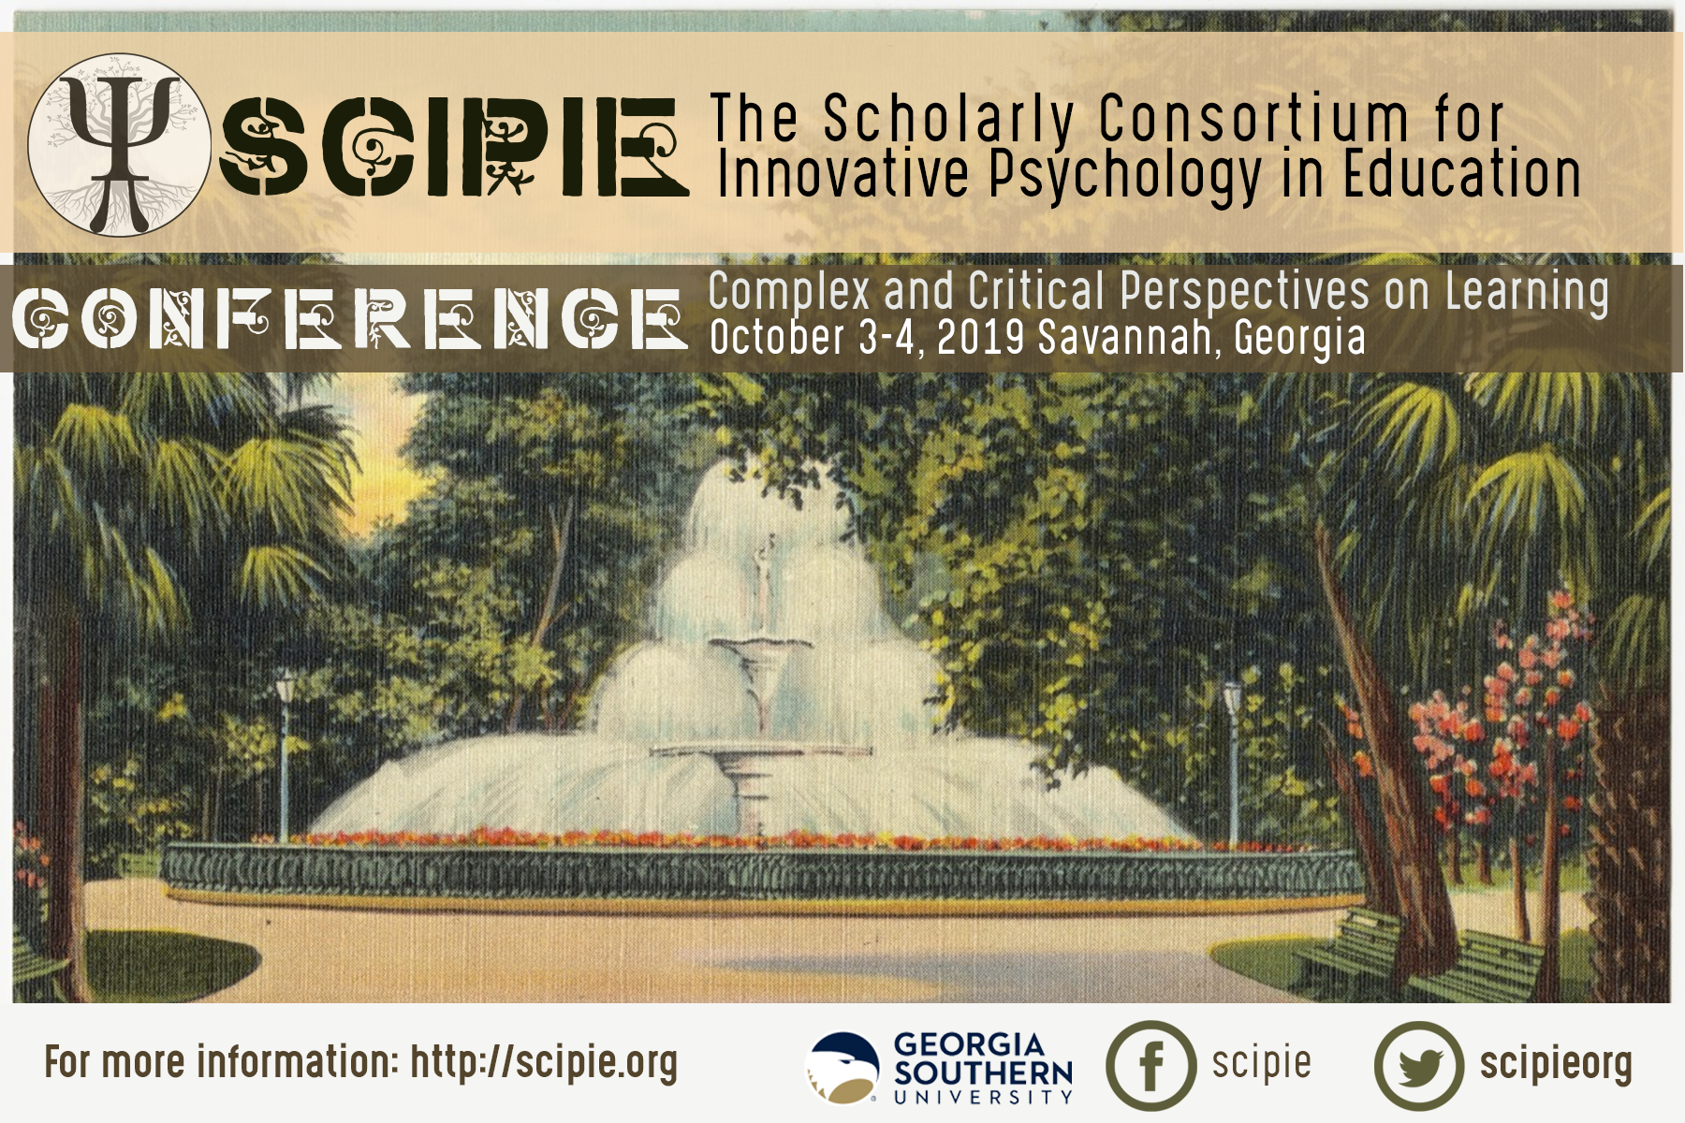
Graduate Student Posters
- Ferdous Ahmed (Georgia Southern University): Using social network analysis to study of classroom engagement, integration, and involvement
- Ahmet Basyigit (University of Oklahoma): Comparative Study on Perspectives of Kindergarten Teachers on Values Education: The Case of Turkey and the USA
- Candice Bolding & Luke J. Rapa (Clemson University): The Influence of Marginalized Social Identities on Undergraduate Students’ Engineering Identity: A Preliminary Assessment
- Cari Allyn Brooks (Clemson University): Social Empathy as Developmental and Community Asset: Directions for Pedagogy
- Raelynn Frazier (University of Nevada Las Vegas): Exploring the role of Epistemic Cognition and Self-Efficacy in the Career Decision-Making Processes of College Students
- Jenna Furman, Sharon Zumbrunn, & Christine Bae (Virginia Commonwealth University): Motivation of Students in Juvenile Detention: A Brief Review of Motivation Frameworks with At-Risk Adolescents
- Alexandra Gilbert (Georgia Southern University), Jonathan Hilpert, & Gwen Marchand (University of Nevada Las Vegas): Understanding Scientific Productivity and Collaboration in a Research Laboratory through Social Network Analysis
- Precious Hardy (University of Missouri – Columbia): Parenting Success: Examining the Mediating Effects of Parental Involvement on Student Achievement
- Monica Hernandez-Johnson (University of Nevada Las Vegas): Critical Mixed Methods Research: QuantCrit, Cultural Intuition, and Counterstories
- Mary Hershberger & Terri Flowerday (University of New Mexico): Exploring social support for first-semester college students through latent profile analysis
- Imogen Herrick (University of Southern California): Climate Change in the Classroom: Teacher Beliefs in the context of NGSS Christie Higgins-Gardner (University of Nevada Las Vegas): Living in a digital world: Who is included and how do the nuances of inclusion shape student engagement when social networking sites are used in the classroom?
- Laura Jakiel, Alysia Roehrig, & Jeannine Turner (Florida State University): Revising the Future Time Perspective Scale: A Study of Reliability and Validity
- Shannise Jones (University of Missouri): Identifying and Defining the Nuances of Sexual Consent from the Perspectives of Students at the University of Missouri: A Pilot Study
- Preeti Kamat (Virginia Commonwealth University): A Cross-Cultural Review of Effective Professional Development for Improving Student Motivation and Engagement in K-12 Schools in the United States, Europe and Asia
- Alana Kennedy (University of South Carolina): An Examination of Self: How Students of Color Select and Apply Self-Regulated Learning Strategies in Academic Settings
- Melissa Kuhn & Joanna Gardner (Old Dominion University): A Complex Systems Perspective on Cases of Testing Irregularities in School Systems
- Andrea Kunze, Larry Washington, & Rodney Hopson (University of Illinois at Urbana-Champaign): Using Design-Based Thinking to Change Individual and Group Values Towards Privilege
- Daphne Mills (Virginia Commonwealth University): Examining the Associations Between Parental Socialization and Science Motivation in Rural African American Adolescents: A Study Of Expectancy-Value Theory
- Georgia McKown, Kristina Randall, Shana Hirsh (Clemson University), Jason Chow, & Shannon Nemer (Virginia Commonwealth University): Evaluating the Effect of Embedded Responses in Multimedia-based Instruction with Preservice Teachers: A Conceptual Replication
- Shannon Nemer (Virginia Commonwealth University): An Adaptation and Psychometric Evaluation of the Teacher Attribution Measure for Early Elementary (TAM-EE)
- Monica Romero & Steven Whitney (University of Missouri, Columbia): The Reading Achievement Growth of English Language Learners
- Wendy Wakefield & Mia DeLaRosa (Arizona State University): Critical Inquiry Professional Development Model for Experienced Teachers: Expanding Agency for Responsive Teaching
- Kelly Ross & Benjamin Heddy (University of Oklahoma): Exploring the Relationships between Transformative Experience, Emotions, and Interest in Middle School Engineering Courses
- Abigail Stephan (Clemson University): Transferring Learning in the Family and Community to the Classroom: A Review of Intergenerational Learning Experiences for Marginalized Youth
- Ian Thacker (University of Southern California): The Influence of Numerical Estimation Skills and Epistemic Cognition in Conceptual Change
- Melissa Warr (Arizona State University): Learning Professional Ways of Being: A Design Approach to Professional Learning
- Nancy Webb (University of Nevada Las Vegas): Self-Regulated Learning and Mobile Learning
- Ashlee Lester & Sharon Zumbrunn (Virginia Commonwealth University): A new approach to understanding student engagement and differences in afterschool programs

